Truth and Lies – Russian and Western doublespeak
There is no war going on in Ukraine, just a “special military operation” in which Russia is not targeting civilians and is acting in self-defence against a cabal of Nazi aggressors. Pictures of collapsed buildings and dead women and children in the streets are fake. Ukrainians are bombing their own people to try to make Russia look bad in the eyes of the world.
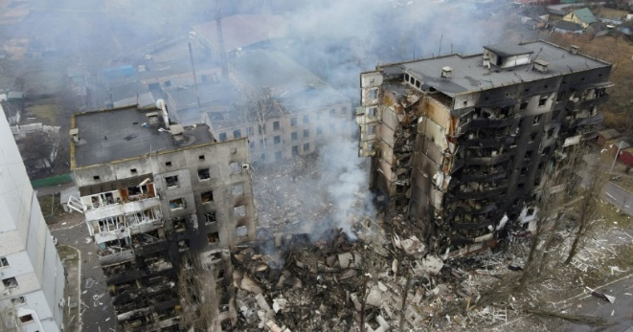
For the West, the lies put out the Kremlin are easy to discern, but our own society’s relationship with truth is becoming increasingly undermined by new philosophies. These result in lies which people in other parts of the world find equally easy to spot.
The mantra “trans women are women, trans men are men” reflects a move away from our spiritual heritage and biblical faith tradition that God made us male and female and we are a unity of body, soul and spirit. In forsaking this, we are embracing the lie that sex and gender are human constructs rather than divine realities. There are a tiny number of people who in our fallen world are born with indistinct sexual features and even chromosomal abnormality. Their sexual identity may be a journey of discovery which everyone should accept is not straightforward.
However, according to the new thinking, gender is never something we can recognise as God-given when someone is born, but something that is always merely “assigned” according to social convention. If someone feels passionately that their “inner being” is at variance with their physical anatomy then the dominant philosophical voices are demanding the right for their physical anatomy to be changed and/or the rest of society to legally and socially accommodate their feelings in order to ameliorate their sense of gender dysphoria. On the other hand, attempts by anyone, even with full consent, to help align people’s psychological identity to their biological make-up should be banned as it offends LGBT sensibilities. This is a modern expression of ancient Gnosticism. Physical matter is of no consequence and if there is a conflict between our mystical sense of identity and the body our souls inhabit, the body can be tampered with as much as we like, but the inner self is sacred and must suffer no intervention.
People’s sex on their birth certificates can now be changed. Children can have puberty blockers, cross sex hormones and be taken abroad for “gender re-assignment”, which is Orwellian doublespeak for genital mutilation. Under the new philosophical regime, men can be pregnant and victims of rape have to accept that their attacker might have to be referred to as a woman. The terms ‘mother’ and ‘father’ are being erased from official discourse.
Lies are impossible to sustain without a tangled web of inconsistency and absurdity. So, the prime minister’s double U-turn on banning “conversion therapy” highlights this. Hoping to be regarded by the electorate as socially progressive and compassionate, he wanted to ban any practice which might indicate a homosexual identity is not something to be protected at all costs. Rather than being honest about this, the vague and undefined language of “banning conversion therapy” was and is used to imply that the aim is simply to protect people from coercive and abusive practices (even though the law already prohibits anything coercive and abusive). Things that are obviously evil and illegal like “corrective rape” and electric shock treatment are deliberately conflated with prayer and counselling.
Government lawyers will have explained to ministers that framing a law to ban something requires the discipline of actually defining what you are banning. Their unsurprising conclusion was that banning “conversion therapy” was “too legally complex.” Are church leaders really to be criminalised for teaching traditional, biblical sexual ethics and counselling and praying for their flock to abide by this teaching? Is there to be a legal prohibition on inner healing that might result in a change in sexual desires and gender identity? How do you frame a law which bans therapeutically helping people to move away from homosexuality and transgenderism but not towards it?
The political backlash following the leak of the news that the government was dropping the idea of banning “conversion therapy” immediately produced another U-turn. Homosexuality was, after all, to be protected against the “conversion therapy” bogeyman, but not transgenderism. More outrage predictably followed and the government had to cancel its flagship LGBT international conference because of a mass boycott.
The decision to exempt transgenderism from the “conversion therapy ban” gave the game away. If outlawing “conversion therapy” is in truth about prohibiting only practices that are sinister, coercive and abusive, the ban should of course apply to people who identify as transgender and indeed it should apply to anyone wanting any kind of identity change. However, the revelation that the prime minster and others know that banning “conversion therapy” generally might actually prevent good therapy to help people to move away from transgenderism (i.e. non abusive, responsible, loving help) shows how this proposed legislation is not about promoting truth, consistency and people’s wellbeing but merely swaying with the wind of perceived cultural opinion in a way that is politically advantageous. So, it is believed that as far as the voting public is concerned, “being gay” is unproblematic, but “being transgender” is still not something we ought to uncritically affirm, particularly for children. Therefore, “conversion therapy” should continue to be available to transgender people, even though in relation to homosexuality, it is apparently “deeply abhorrent.”
Although I would contend that the spiritual and philosophical roots of transgenderism are linked to those of homosexuality, the level of doublethink necessary to sustain the former is greater. So, many instinctively feel uncomfortable with the idea of male to female transgender people competing against women in sports, having access to women’s changing rooms, hospital wards, domestic violence refuges and prisons, especially if they maintain their male appearance and genitalia. But if “trans women are women” then of course they should be able to compete against other women and have access to women only spaces. They are women and should be treated as such for all purposes. Once a pseudo-therapeutic fiction is regarded as fact, it is of no use complaining this has undesirable consequences.
However, even those in the vanguard of the new religion, like Labour politician Lisa Nandy, find themselves caught up in logical and philosophical absurdity. So, when she was campaigning for the leadership of the party she was asked, in February 2020, if a transgender person (known as Zoe Lynes) who as a biological man (known as Christopher Warton) had raped a girl, should be imprisoned in a women’s prison she replied, “I believe fundamentally in people’s right to self-ID. I think trans women are women, I think trans men are men, so I think they should be accommodated in a prison of their own choosing.”
She was completely oblivious as to the nonsense of her position. If a trans woman is a woman, a trans woman should not have a choice as to where they are imprisoned (as if going to prison was like choosing a hotel), but should be required to go to a woman’s prison. Going to a male prison whilst identifying as a female would be highly dangerous - a lot more dangerous than any “conversion therapy”.
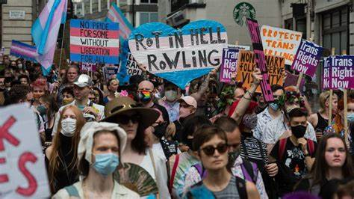
People might say that lies are more serious when they concern a country being invaded than when they are about people’s strongly felt identities. Leo Blair apparently explained to his father, the former prime minister, how he should understand the trans issue. “There are facts and there are feelings. Right now, dad, feelings are more important.” But to be aghast at one kind of lie and relaxed about another puts us on a dangerous path. One of the things that helps shore up support for Putin in Russia is the sense that the West is decadent and hostile to truth as regards things like gender. Countries which deny the truth about such a fundamental aspect of human existence and who “cancel” those with gender-critical views are not best placed to philosophically counter other countries that use lies to cover aggressive wars and denounce their dissenting citizens as “traitors” and “scum.”
Martin Kuhrt 10/04/22

